ATS job posting domains
These top 10 represent about 80% market share

Google Advanced Search: https://www.google.com/advanced_search

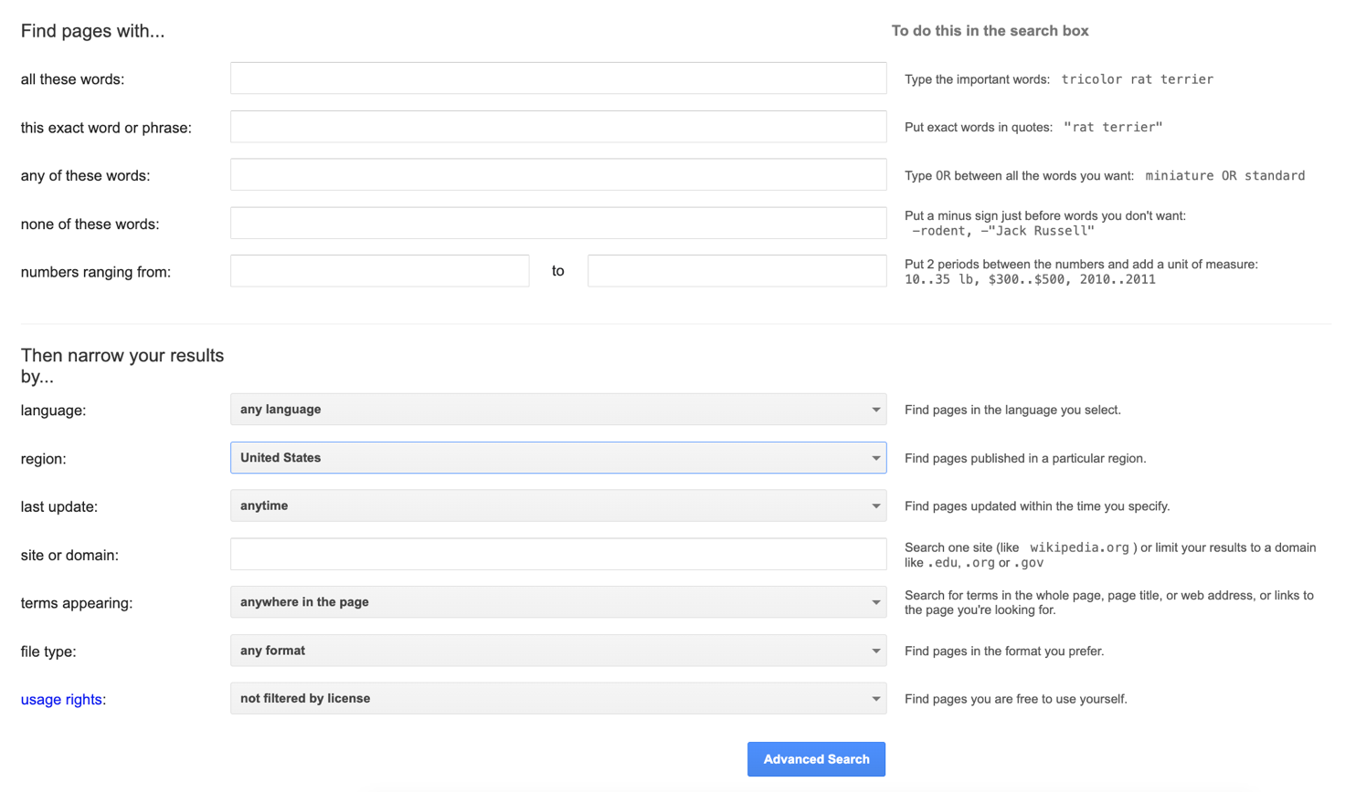

- Workday:
  - .wd1.myworkdayjobs.com
  - .wd3.myworkdayjobs.com
  - .wd5.myworkdayjobs.com
- Taleo (by Oracle):
  - .taleo.net
- Success Factors (by SAP):
- iCIMS:
- Greenhouse software: boards.greenhouse.io
- Kenexa-Brassring (by IBM):
  - https://www.similartech.com/compare/ibm-kenexa-vs-ibm-kenexa-brassring
- SmartRecruiters: jobs.smartrecruiters.com
- Jobvite: jobs.jobvite.com
- Lever: jobs.lever.co
- Ultipro (by Ultimate Software):
  - recruiting2.ultipro.com
  - recruiting.ultipro.ca
- Paylocity: recruiting.paylocity.com

- Tek Systems: careers.teksystems.com
- Oracle:
  - fa.us2.oraclecloud.com
  - fa.us6.oraclecloud.com
- Telemetry: ttcportals.com/jobs
- ADP: https://recruiting.adp.com/
- Workable: https://apply.workable.com/
- Breezy: breezy.hr

Other site domains:
- joinrise.com
- otta.com
- mentra.com
- join.com
- breezy.hr
- ashbyhq.com
- smartrecruiters.com
- 4dayweek.io
- applytojob.com/apply/
- https://www.workatastartup.com/
- themuse.com/jobs/ OR
- opentoworkremote.com/jobs
- peopleopsjobs.io/job)
- AND (“JOBTITLE” AND "JOB2")

